G-BANK

Users Manual in English
www.GAMEBOY-ADVANCE.net

Thanks for your purchasing G-BANK
For correct use, make sure to finish reading the manual

Table of contents

Attention…………………… …………………....…3
Structures of G-Bank…… …. ………….…….………..4
Features and functions ………………..…………..….. 5
Installation of drive………………………………………6
Operation key …………….……...………...………...7
System screen……………………………………………8
Function selection………..………..………………..9~13
How to run game file in BANK ….. ……………..14~57
Quick operation………………………………………58~62
Product configuration…………………………………..63
Warrantee service and service……………………64~65

Attentions

G-BANK is a very fine electronic application, please pay attention on the followings when use：

- Prevent from strong hit to damage body and inside parts
- Avoid improper force or angel to insert the disk
- Prohibit to disintegrate or remodel
Never arbitrarily disintegrate, remodel, or repair
■Far away from high heat or hot source：
Never put the product in the spot under direct sunshine, in high temperature, or in hot and closed space, to prevent from over heat, mal-function, and shortening life cycle
- Away from humid, contact with fluid, and substance invasion：
Get away from fluid and substance invasion, or wet hand for electric shock

Structures of G-Bank

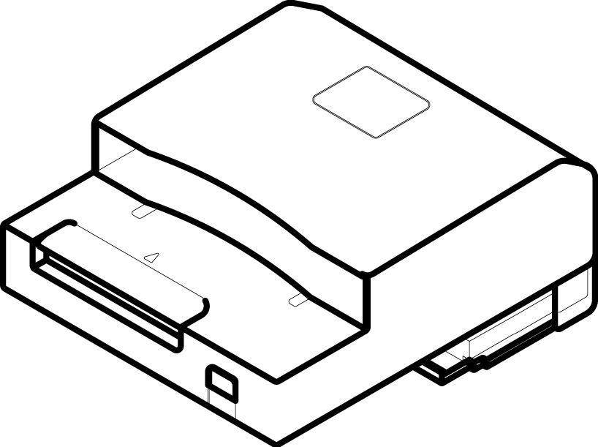
Bank:128Mb
Flash memory

Card slot
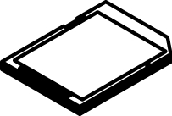

SD/MMC Card USB Original Cassette slot
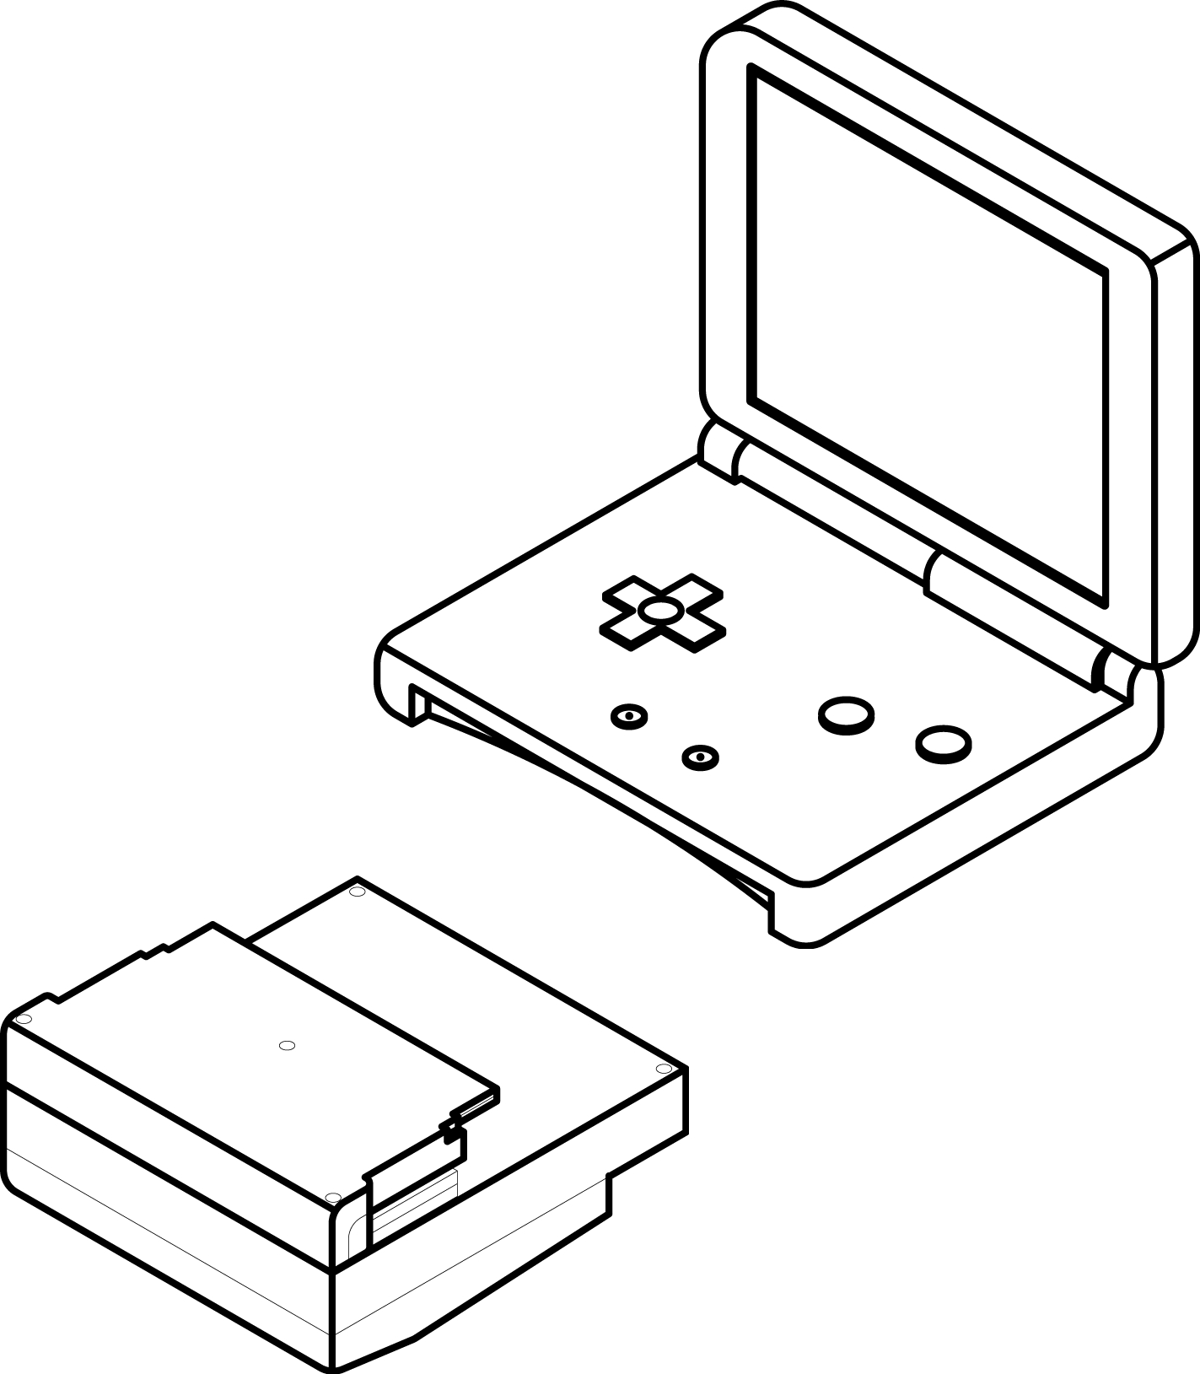
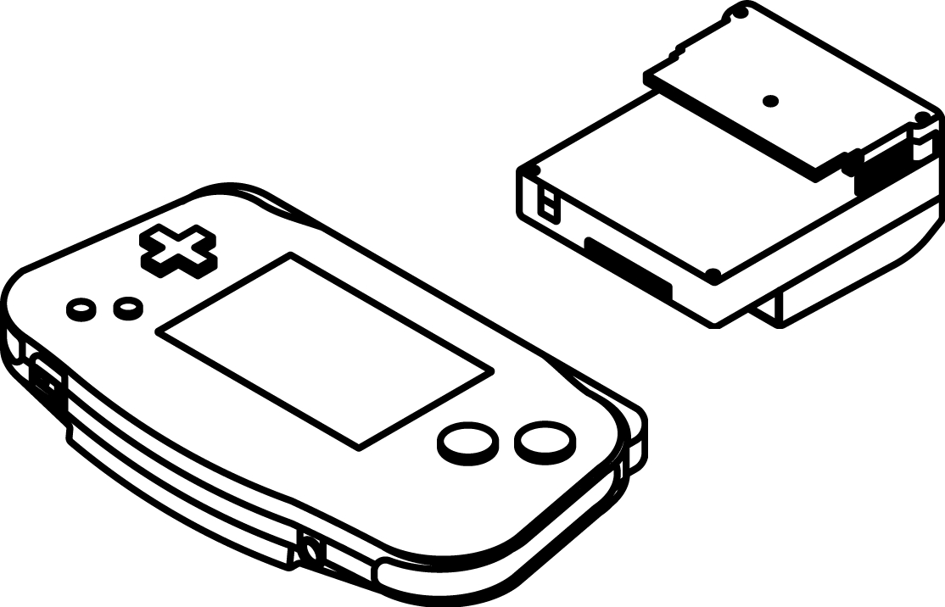

Features and functions

- G-Bank is a super mini and mobile saving drive, and a completed file manager when connection with GBA
- SD / MMC card reading
- With 16 groups of memory functions to save file progress
- Allowable for download and run a variety of software, such as video making, electronic book compiling, music playing, and photo and figure viewing.
■Provide 128Mb Flash memory (called as Bank) and allowable to read SD / MMC card, for large amounts of files【Note】：GBA with the unit of M bit (1byte = 8bit), and for the file of 32Mb：
 | G-Bank | SD64MB | SD128MB
Memory | 128Mb | 512Mb | 1024Mb
Numbers of software file | 4 | 16 | 32
■Multi-language interface for easy operation
■Supporting memory modes：SRAM, EEPROM4K, EEPROM64K, FLASH, and FLASH1M

Installation of drive

【Step1】Equip G-Bank with Machine
【Step2】link between G-Bank and USB line of PC
【Step3】Start power of game machine
【Step4】Install the drive of G-Bank in the PC
(File ：SETUP.EXE)
No drive needed for Win Me / 2000 / XP OS
【Step5】Enter ”my computer” to add ”portable hard drive”
for file saving

Operation key

【Operation key】：
- Cross button up and down：move the arrow mark
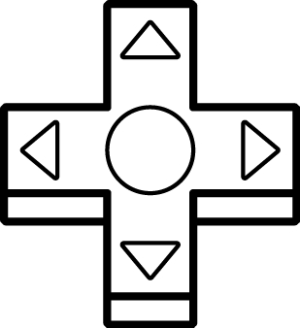

(2)A Key：”decide” the motion
B Key：”cancel” the motion, and back to the previous
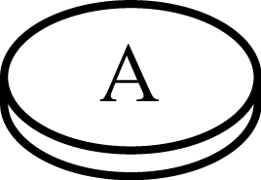
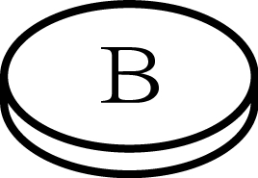

(3)L、R Keys：” shift function”

Previous page Next Page




System screen

1. Status message
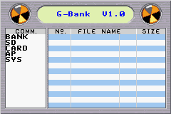
2. Functions 3. File message
【Notice】Each time when finishing function selection, turn off the power of GBA and restart to enter Game Bank

Function selection：BANK
1 run：run the software file
1
2
3
4
5
2 SD：transport files in bank to SD card
3 del：delete files in bank
4 dir：show file saving in bank
5 format：format memory in bank, and clear all files

Function slection：SD
6
7
8

6 >bank：transport files in SD to G-Bank
7 >del：delete files. Use “del” will clear files in SD card
8> dir：show file saving in SD card

Function selection：CARD
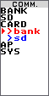 | 9  10

9 >bank：transport files in cassette to Bank
*Notice：to run system in G-Bank, it is essential to download those files from cassette
10 >sd：transport files in cassette to SD card
【Notice】：allow save files from cassette in SD card, and then download to G-bank when running

Function selection：AP

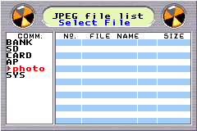

11

11>photo: View digital photo and image files. The function is used to play photo file
Function selection：SYS
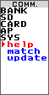 | 12  13  14
12 help：key description
13 match：match for progress files. G-Bank provide 16 saving slots for game progress saving. If the progress unable read correctly, the function may be used to modify the match between software file and progress file
14update：system update. Update operation interface of G-Bank
How to run game file in Bank？

Prepare:：
Put G-Bank in cassette slot of GBA / GBA SP, and insert cassette and turn on power. The screen for G-Bank operation shows as below
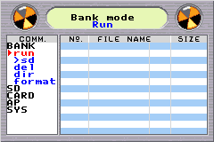
【Step1】：Move the arrow mark to ”run” under Bank in COMM. list, and press A
.【Step2】：Select the file to run and press A
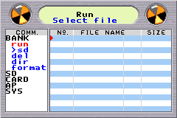

【Step3】：Select saving mode：The screen shows 5 modes, including SRAM, EEPROM4K, EEPROM64K, FLASH, and FLASH 1M, and the system detects the most proper one (with red arrow). Press A to run it, or select others when un-match for file saving

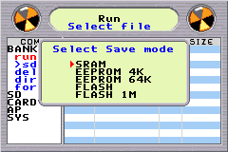
【Notice】Enter the game and shut down GBA. Restart to back to Bank system operation

【Add-on descriptions】

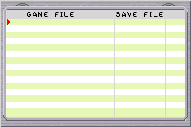
01 GAME1 GBA 01 GAME1 SAV

When download files to Bank and first run them, the system will show the top screen, and press A to SAVE FILE if the saving mode is “unset”. Select from 16 saving slots with the up and down key. For those files not for saving, select ”no save” and press A, then B back to Step 3

How to transport files in Bank to SD card？

Prepare:：
Put G-Bank in cassette slot of GBA, and insert cassette and SD card and then turn on power. The screen for G-Bank operation shows as below
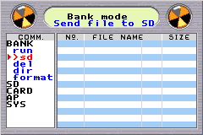
【Stp1】：move the arrow mark to ”>SD” under BANK, and press A
【Step2】：Select file types and press A to enter Step3.
There are two types, including Game file and Save file for selection. The system will list available files under the selected type

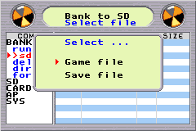

Notice：ROM file =>select software to run(*.GBA)
Save file =>select progress to save (*.SAV)

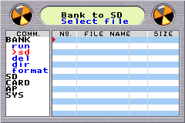
【Step3】：Select the file in the list for transporting, and press A to Step 4

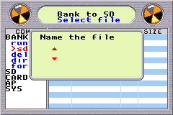
【Step4】：Use the cross button to edit the file name in the window, and press A key to Step 5 after naming to transport files

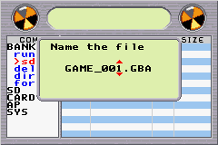
【Step5】：During transporting, the screen will show the progress, and the job is down with 100% progress

【Notice】：Put the arrow mark on “dir” under SD in COMM. List, and press A key to check the file just transported to SD card
How to delete files in Bank？

prepare:：
Put G-Bank in cassette slot of GBA, and insert cassette and SD card and then turn on power. The screen for G-Bank operation shows as below
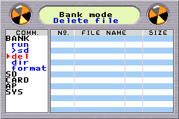
【Step1】：move the arrow mark to “del” under BANK in COMM. List, and Press A key to Step 2
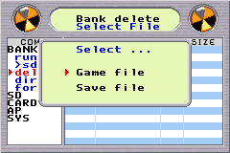
【Step2】：select the file type, and press A key to Step 3

【Step3】：Select the file in the list, and press A key to Step 4
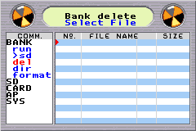

1 GAME1 GBA 32Mb

【Step4】：The message of “Are you sure?” shows up. Select ”Yes” to delete the files, or “No” to back to the previous page
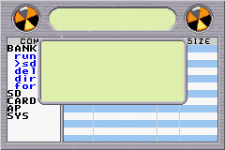
Are you sure?
Yes
No

【Step5】：During deleting, the screen will show the progress, and the job is down with 100% progress
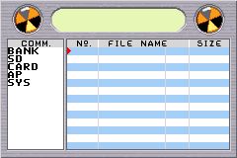

Deleting 50%

. How to check file saving inG-Bank？

prepare:：
Put G-Bank in cassette slot of GBA, and insert cassette and SD card and then turn on power. The screen for G-Bank operation shows as below

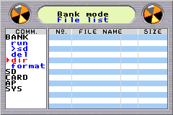
【Step1】：move the arrow mark to “dir” under BANK in COMM. List, and press A key to Step 2

【Step2】：select file type, and press A key to Step 3

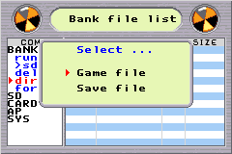

【Step3】：On the file list area, information about all files in Game bank will be shown

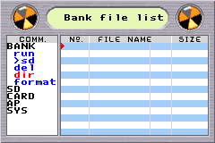
How to format G-Bank？

Prepare：
Put G-Bank in cassette slot of GBA, and insert cassette and SD card and then turn on power. The screen for G-Bank operation shows as below

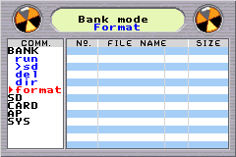
【Step1】：move the arrow mark to “format” under BANK in COMM. List, and press A key to Step2
【Step2】：The message of “Are you sure?” shows up. Select ”Yes” to format, or “No” to back to the previous page

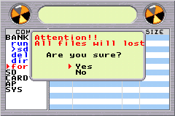

【Step3】：During formatting, the screen will show the progress, and the job is down with 100% progress

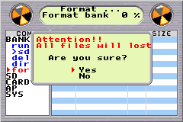

How to transport files in SD card to G-Bank？

Prepare：
Put G-Bank in cassette slot of GBA, and insert cassette and SD card and then turn on power. The screen for G-Bank operation shows as below

【Step1】：move the arrow mark to “>bank”” under BANK in COMM. List, and press A key to Step2

【Step2】：Select file type from two (Game file and Save file) on screen, and press A Key to Step 3

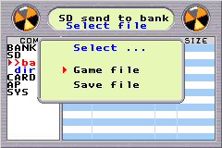

【Step3】：Select files in the list, and press A key to start transporting

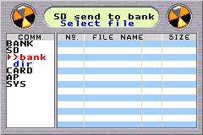

1 GAME1 GBA 32Mb

【Step4】：During file downloading, the screen will show the progress, and the job is down with 100% progress

Loading 60%

How to check file saving in SD card？

Prepare：
Put G-Bank in cassette slot of GBA, and insert cassette and SD card and then turn on power. The screen for G-Bank operation shows as below
【Step1】：move the arrow mark to “dir”” under BANK in COMM. List, and press A key to Step2
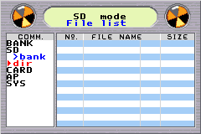

【Step2】：In the file list area, information about all files in SD card will show
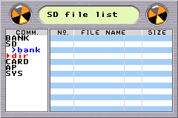

How to transport files in Card to G-Bank？

Prepare：
Put G-Bank in cassette slot of GBA, and insert cassette and SD card and then turn on power. The screen for G-Bank operation shows as below
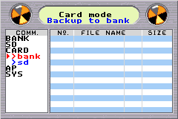
【Step1】：Move the arrow mark to ” > bank” under CARD in COMM. List, and press A key to step 2

【Step2】：Select the file name with the cross button, and Press A key to Step 3

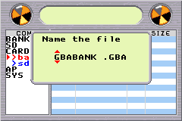

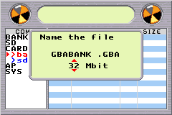
【Step3】：Select the file size in the same window as the previous step, and press A to transport.

【Step4】：During backing up, the screen will show the progress, and the job is down with 100% progress

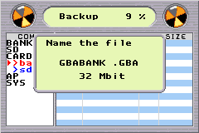

How to transport files in Card to SD card？

Prepare：
Put G-Bank in cassette slot of GBA, and insert cassette and SD card and then turn on power. The screen for G-Bank operation shows as below
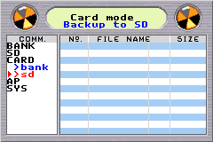
【Step1】：Move the arrow mark to ”>sd” under CARD in COMM. List, and press A key to Step 2

【Step2】：Select the file name in the window of file name, and Press A key to Step 3

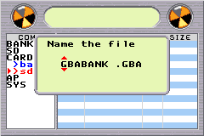

PS : the system will automatically detect the file name, or you may manually key in the file name without detecting result .

【Step3】：Select the file size, and press A key to transport it

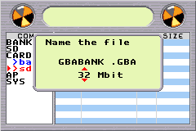

PS : The system will automatically detect the file size

【Step4】：During backing up, the screen will show the progress, and the job is down with 100% progress。

Notice：The function can only correspond to the cassette of original copy, therefore, any problems beyond anticipation caused by non-original copy will not be covered by free services of the Company.

How to view digital photos and image files？

Prepare：
Put G-Bank in cassette slot of GBA, and insert cassette and SD card and then turn on power. The screen for G-Bank operation shows as below

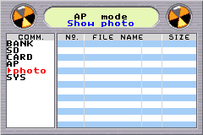
【Step1】：Move the arrow mark to ”photo” under AP in COMM. List, and press A key to step 2
1 photo jpg 50k

【Step2】：Select from files of compatible format which are automatically shown in the file list area, and press A key to Step 3
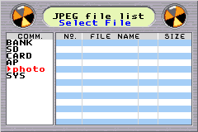
【Step3】：Show digital photos or image files.
【Notice】：The system will show photos or images with the full screen

How to use Help？

Prepare：
Put G-Bank in cassette slot of GBA, and insert cassette and SD card and then turn on power. The screen for G-Bank operation shows as below
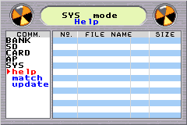
【Step 1】：Move the arrow mark to ”help” under SY in COMM. List, and press A to step 2

【Step 2】：Enter the button list, and press B to quit and back to the previous step

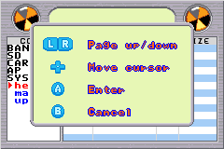

How to use Match(progress saving match) ？

Prepare：
Put G-Bank in cassette slot of GBA, and insert cassette and SD card and then turn on power. The screen for G-Bank operation shows as below

【Step1】：Move the arrow mark to “match” under SYS in COMM. List, and press A to step 2
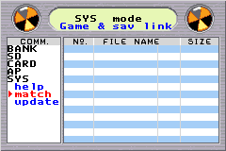
【Step2：】

01 GAME1 GBA 01 GAME1 SAV
【Window description】：The window is divided into left and right columns, the left with file list in G-bank and the right with distribution and use of 16 progress saving slots. Entering the window, select the file for match in the left column, and then on the right side when the arrow mark shows in the column. Press A to Step3.

【Step 3】：Select the correct progress saving, and press A to ensure

01 GAME1 GBA 01 GAME1 SAV
【Notice】：In the right column, use the cross button to up and down select the progress saving, from 1-16 saving slots and “No save” which can prevent from space occupancy by the file without saving need.

How to use Update？

Prepare：
Put G-Bank in cassette slot of GBA, and insert cassette and SD card and then turn on power. The screen for G-Bank operation shows as below

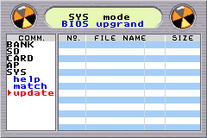
【Step1】：Move the arrow mark to “update” under SYS in COMM. List, and press A to step 2

【Step2】：The system will automatically show the correct update files in the file list area. Select the file, and press A for sure

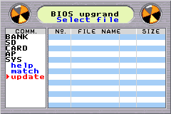

The update files have to be downloaded from SD card to Bank, then ”update” function can be executed

【Step3】：During upgrading, the screen will show the progress from 0%-100%, and the job is down with 100%

Update 90%

Quick operation

1. Download software files to SD card from PC
A. Insert SD card in SD cassette slot of G-BANK
B. Use USB line to connect with PC
C. Install G-BANK drive
D. PC will deem G-BANK as the portable hard disk drive, and please download software files

2. Download SD card to Bank
Enter SD>bank select file type ensure
Select files start downloading

【remark】For the first time downloading, the system will inquire whether save file
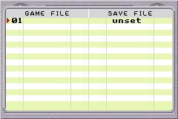

Enter SAVE FILE 1 NOSET(group number unlimited) to run
2 select from1-16(saving file)

quit from file save select files to run enter the system window
*for incorrect order and file name, adjust in SYS>match
3.Run files saved in Bank
Enter Bank>run select files Run
*Back to the system window, shut down and restart

4.Delete files in BANK

Enter BANK>del Enter file list area

Select files to delete Start deleting

5.Format BANK
Enter BANK>format Select from (YES、NO) on the message window, and press A

6. Backup files in BANK to SD card
Enter BANK>SD Enter file area select files run
*It will take long to run the function, and you may do it during rest periods

7.Backup files in cassette to BANK or SD card

Enter CARD>bank file name and file size
Or CARD>sd select files and press A to run
*Use the cross button to select, or press A to preset the file name
*Refer to the original capacity of the file for file size
8.Q&A
Q1. What is Game file?
A: Game files in G-Bank refer to program files in cassette; On Web the group to discuss or research Emulator is called as Roms or Rom code.
Q2.What is Save file?
A: Just as most computer games, some games may not be finished to the end during several hours. For those stopping in the middle, the program will record the playing progress and facilitate the players to continue when next playing. The recorded data file is Save file.

Product configuration

■OS in computer: Windows ME/XP/2000/98 (need driver)
■Built-in Flash memory: 128Mbit
Added memory card: SD / MMC
■Built-in USB reader
■Operation interface edition: English/Chinese/France/Japanese/Arabic/Italia
■Supporting cassette backup
■Supporting file save mode: Eprom/Flash/Sram
■Weight：about 60 grams
■Size：about 70 x 61 x 33 (mm)

Warrantee and service

G-BANK warrantee
■The product is fully qualified under our quality management and rigid inspection. For problems to the product under customer’s normal use and following the user manual, we will provide the free repair service based on the warrantee paper during 6 months since the purchase date. To repair, please take the product and warrantee paper to the sale store.
■During the warrantee period, the repair fee will be charged for the followings
1.Any problem caused by improper operation, remodeling, and inappropriate repair
2.Any damage caused by falling down in moving due to improper storage place broken
3.Any problem or damage and changes of consumptive parts, caused by use conditions not described in the user manual
■Except for repair fees, costs of parts may be charged some depending on parts.

Warrantee
Essential for warrantee repair
Purchaser | Name |  | Telephone
Purchaser | □□□
Sales store | Store & Address | Store stamp |  | Sale date
- The warrantee cannot be used for service without store stamp and sale date
- The warrantee will not be re-issued when lost, and please carefully keep it.
- Web Links:
⇒ G-BANK Review by GAMEBOY-ADVANCE.net
www.gameboy-advance.net/flash_card/game_bank.htm
www.G-BANK.tk

⇒ Download Gameboy Advance Game Roms from:
www.Gameboy-Advance-Roms.com

⇒ GBA ROM Screenshots
www.gba-roms.net/screenshots.htm

